AMPds2 Smart Meter Anomaly Detection
Detection, False-Positive Filtering and Graph-Based Diagnosis
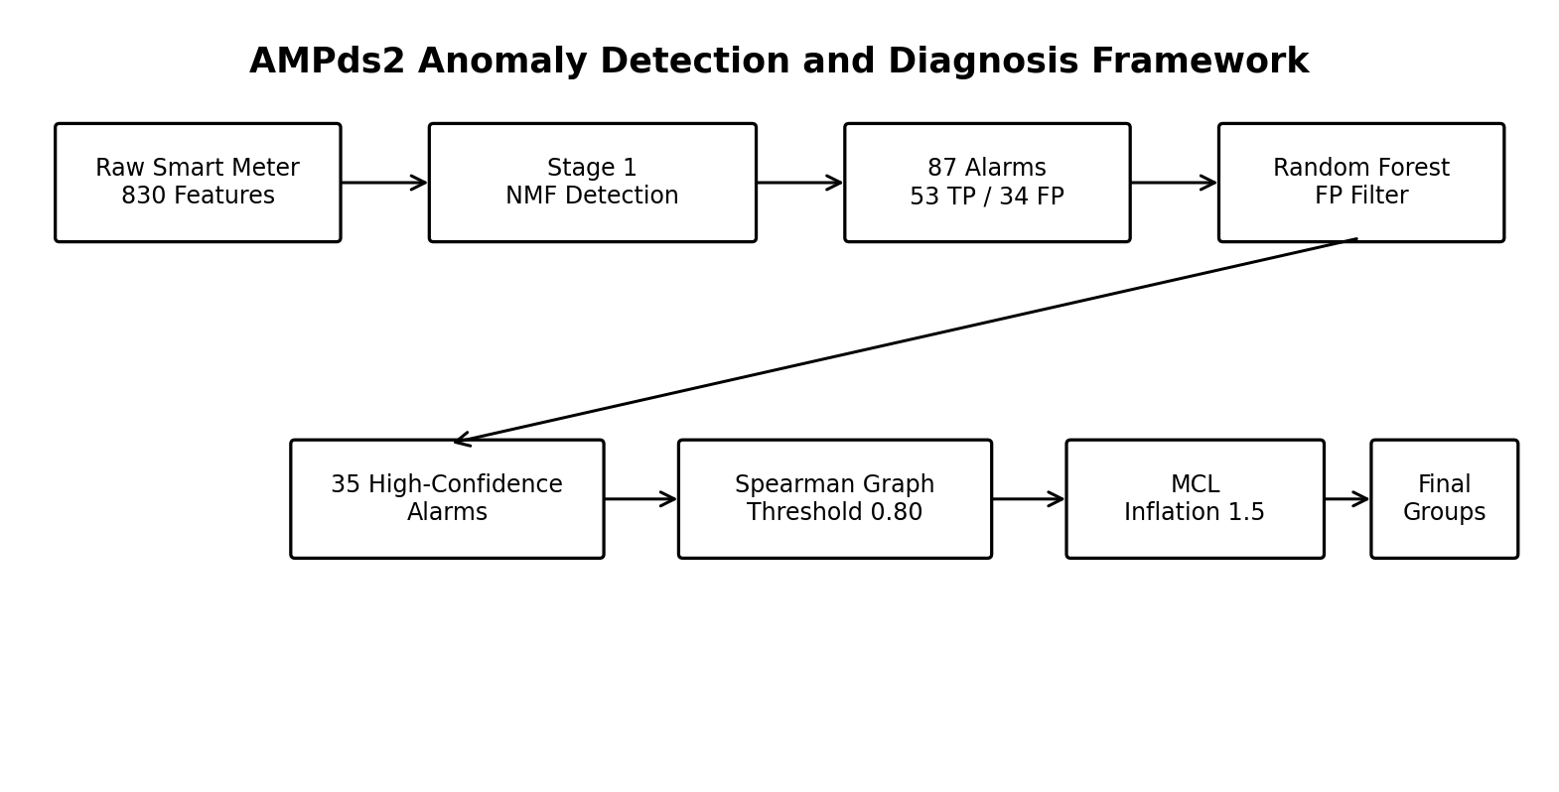

1. System Overview
The framework uses two stages: Stage 1 detects anomalous smart-meter behavior, while Stage 2 filters false alarms and groups the remaining alarms using graph-based clustering.
- Dataset: 5,856 15-minute windows.
- Features: 830.
- Labeled anomaly types: 14.
- Stage 1: unsupervised novelty detection.
- Stage 2: false-positive filtering and graph-based diagnosis.

2. Stage 1: NMF Anomaly Detection
NMF is fitted only on normal training data. The anomaly score combines input reconstruction error and latent reconstruction error.
- K = 40.
- Inverse normal-training MSE feature weighting.
- RGAnomaly score: 0.4 × Input Error + 0.6 × Latent Error.
- Validation threshold selected using maximum F1.

Stage 1 Benchmark
Model | Configuration | Val PR | Val ROC | Test PR | Test ROC | Precision | Recall | F1 | TP/FP/FN/TN
Initial Baseline | K=40, unregularized | 0.4004 | 0.7897 | 0.4113 | 0.7728 | 48.08% | 43.86% | 0.4587 | 50/54/64/711
Best Regularized NMF | alpha_W=0, alpha_H=0 | 0.4004 | 0.7897 | 0.4113 | 0.7728 | 48.08% | 43.86% | 0.4587 | 50/54/64/711
Weighted Recon (1/Var) | Baseline + 1/Var | 0.3846 | 0.7762 | 0.3986 | 0.7570 | 54.67% | 35.96% | 0.4339 | 41/34/73/731
Weighted Recon (1/Std) | Baseline + 1/Std | 0.4091 | 0.7912 | 0.4121 | 0.7716 | 54.05% | 35.09% | 0.4255 | 40/34/74/731
Objective Weighted NMF | 1/Var pre-scaled | 0.3960 | 0.7606 | 0.3848 | 0.7288 | 47.57% | 42.98% | 0.4516 | 49/54/65/711
Best Stage 1 Model | Inverse normal MSE | 0.4634 | 0.7874 | 0.4947 | 0.7981 | 60.92% | 46.49% | 0.5274 | 53/34/61/731

Stage 1 Findings
- Test PR-AUC: 0.4113 → 0.4947.
- Precision: 48.08% → 60.92%.
- False positives: 54 → 34.
- Strong gains were observed for High Usage Low Occupancy, Power Spike, Sustained Overload and Gradual Drift Increase.

3. Stage 2: False-Positive Filtering
A Random Forest biased classifier filters the 87 NMF alarms. Alarms are kept when P(True Anomaly) ≥ 0.70.
- 87 initial alarms: 53 TP and 34 FP.
- 29 of 34 false positives removed (85.3%).
- 30 of 53 true positives retained (56.6%).
- 35 windows passed to clustering: 30 TP and 5 FP.

4. Spearman Graph MCL
The remaining alarms are represented as a graph. Similar windows are connected using Spearman rank correlation, weak edges are removed, and MCL finds anomaly communities.
- L2 normalization + 10-D PCA.
- Spearman rank-correlation adjacency matrix.
- Weak correlations below 0.80 are removed.
- MCL inflation = 1.5.
- Cluster labels use dominant-label majority vote.

Similarity Metric Comparison
Similarity | Threshold | Inflation | Clusters | Singletons | N≥3 | Weighted TP Purity | Purity N≥3
Spearman Rank Correlation | 0.80 | 1.5 | 26 | 23 | 2/26 | 93.33% | 75.00%
Manhattan Laplacian Kernel | 0.80 | 1.5 | 23 | 21 | 1/23 | 90.00% | 70.00%
Cosine Similarity | 0.80 | 1.5 | 17 | 12 | 2/17 | 80.00% | 66.67%
Pearson Correlation | 0.80 | 1.5 | 16 | 12 | 2/16 | 76.67% | 62.50%
RBF / Gaussian Kernel | 0.80 | 1.5 | 10 | 6 | 3/10 | 63.33% | 54.17%
On all 87 alarms in the balanced clustering regime, Spearman achieved 58.49% size-weighted purity and 56.00% purity on N≥3 clusters, compared with 49.06% weighted purity for Cosine.
- Spearman is less sensitive to scaling differences because it compares feature/component rankings.
- Edge pruning removes weak cross-category links and helps MCL form tighter communities.

5. Final Diagnostic Results
The final output contains several discrete anomaly instances and a few non-trivial communities.
Cluster | Dominant Label | N | TP | Dominant Hits | TP Purity | Status
7 | stuck_appliance_off | 6 | 6 | 5 | 83.3% | Non-Trivial
8 | normal (False Alarm) | 4 | 2 | 1 | 50.0% | Non-Trivial
18 | stuck_appliance_off | 2 | 2 | 2 | 100.0% | Micro-Cluster
0 | weekend_pattern_on_weekday | 1 | 1 | 1 | 100.0% | Discrete
1 | sustained_overload | 1 | 1 | 1 | 100.0% | Discrete
2 | stuck_appliance_off | 1 | 1 | 1 | 100.0% | Discrete
4 | sensor_glitch | 1 | 1 | 1 | 100.0% | Discrete
5 | high_usage_low_occupancy | 1 | 1 | 1 | 100.0% | Discrete
12 | power_spike | 1 | 1 | 1 | 100.0% | Discrete
13 | stuck_appliance_on | 1 | 1 | 1 | 100.0% | Discrete
14 | multiple_high_power_simultaneous | 1 | 1 | 1 | 100.0% | Discrete
23 | impossible_appliance_combo | 1 | 1 | 1 | 100.0% | Discrete
3,15,19 | normal (False Alarms) | 3 | 0 | 0 | 0.0% | Purged FP

Final Findings
- Size-weighted TP purity: 93.33%.
- Purity on clusters with N≥3: 75.00%.
- Spearman was the strongest tested graph similarity metric.
- The complete pipeline combines NMF detection, FP filtering and graph-based MCL diagnosis.

6. Artifact and Codebase Index
File / Artifact | Description
complete_system_2.py | Inverse-MSE NMF + Spearman Graph MCL + cluster labeling.
complete_system_1.py | Baseline Cosine Similarity MCL + Tier 4 FP filtering.
best_model_yet.py | Stage 1 NMF detection with inverse MSE weighting.
similarity_experiments.py | Cosine, Spearman, Pearson, RBF and Manhattan comparison.
similarity_metrics_comparison.csv | Similarity metric comparison results.
nmf_experiments_results.csv | NMF regularization and feature-weighting results.
result.md | Executive summary.

